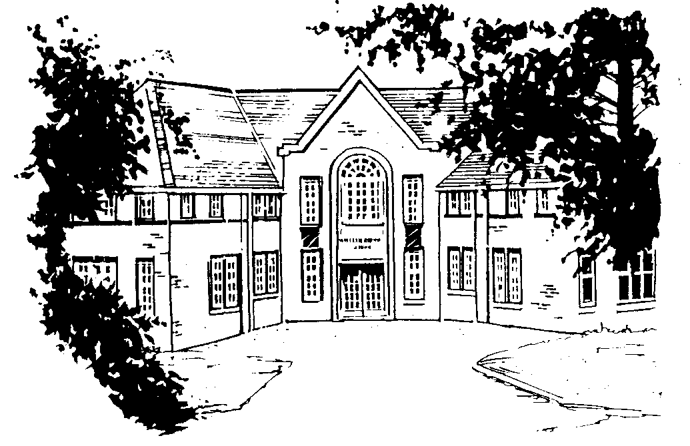
William Rhodes Primary and Nursery School

Hunloke Avenue, Boythorpe, Chesterfield, S40 2NR
Tel/Fax: 01246 234626
Headteacher: Mrs Rachel Purvis
info@williamrhodes.derbyshire.sch.uk

APPLICATION FOR PUPIL LEAVE OF ABSENCE FOR EXCEPTIONAL CIRCUMSTANCES

Name of Pupil: |  | Year Group:
Names of Parent/Carers:

Address:
I / We wish to apply for our child to be absent from school for EXCEPTIONAL CIRCUMSTANCES.
The Department for Education does not consider the following circumstances to be exceptional;
availability of cheap holidays / days overlapping with the beginning or end of term /
birthday of pupil or family member

Date from: | Date to: |  | Total number of school days:
Please supply in as much detail as possible the reason for your request and why you feel it is exceptional circumstances: Continue overleaf if required

Please list below other pupils also applying for the same exceptional absence who currently attend either;
Brampton Primary, Parkside Community, Spire Infants, Spire Juniors or Whitecotes Primary Schools
Name of Pupils: |  | Schools:
Signed (by both parents / carers if applicable) _________________________________

_________________________________

Date _________________________________ THIS FORM SHOULD BE SUBMITTED TO THE HEADTEACHER AT LEAST 2 WEEKS BEFORE THE DATE OF REQUESTED LEAVE.

